QUESTION 1
- Description of the dataset
?crabs
The crabs data frame has 200 rows and 8 columns, describing 5 morphological measurements on 50 crabs each of two colour forms and both sexes, of the species Leptograpsus variegatus collected at Fremantle, W. Australia.
- Loading the data set and structre
crabs
head(crabs)

sp sex index FL RW CL CW BD
1 B M 1 8.1 6.7 16.1 19.0 7.0
2 B M 2 8.8 7.7 18.1 20.8 7.4
3 B M 3 9.2 7.8 19.0 22.4 7.7
4 B M 4 9.6 7.9 20.1 23.1 8.2
5 B M 5 9.8 8.0 20.3 23.0 8.2
6 B M 6 10.8 9.0 23.0 26.5 9.8

Structure of the data
str(crabs)

data.frame': 200 obs. of 8 variables:
$ sp : Factor w/ 2 levels "B","O": 1 1 1 1 1 1 1 1 1 1 ...
$ sex : Factor w/ 2 levels "F","M": 2 2 2 2 2 2 2 2 2 2 ...
$ index: int 1 2 3 4 5 6 7 8 9 10 ...
$ FL : num 8.1 8.8 9.2 9.6 9.8 10.8 11.1 11.6 11.8 11.8 ...
$ RW : num 6.7 7.7 7.8 7.9 8 9 9.9 9.1 9.6 10.5 ...
$ CL : num 16.1 18.1 19 20.1 20.3 23 23.8 24.5 24.2 25.2 ...
$ CW : num 19 20.8 22.4 23.1 23 26.5 27.1 28.4 27.8 29.3 ...
$ BD : num 7 7.4 7.7 8.2 8.2 9.8 9.8 10.4 9.7 10.3 ...

The crabs data set is a data frame with 200 observations and 8 variables.it has 6 numeric variables and 2 categorical variables.
c)
f_table_sp.sex <- table(crabs$sp, crabs$sex)
print(f_table_sp.sex)

F M
B 50 50
O 50 50

Frequency table for species
f.table.sp<-table(crabs$sp)
print(f.table.sp)

B O
100 100

Frequency for sex
f.table.sex<-table(crabs$sex)
print(f.table.sex)

F M
100 100

d)Bar chart summarizing the group compositions
par(mar=c(4,4,3,1))
barplot.group<-barplot(f_table_sp.sex ,beside=TRUE, xlab="Species", ylab="Frequency", main="Group Composition of Crabs",col=3:4)

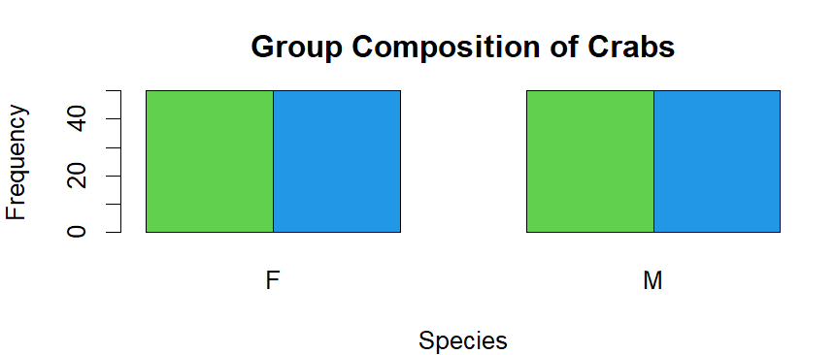
Figure 1.1. A bar chart on group compositions

e) The data set is balanced across all the four groups each combination has the same amount of crabs.

QUESTION 2
a)
##Boxplot of BD for four groups defined by species and sex

Boxplot_BD_sp_sex<-boxplot(crabs$BD[crabs$sp == "B" & crabs$sex == "M"], crabs$BD[crabs$sp == "B" & crabs$sex == "F"],crabs$BD[crabs$sp == "O" & crabs$sex == "M"],
crabs$BD[crabs$sp == "O" & crabs$sex == "F"],
names = c("Blue M", "Blue F", "Orange M", "Orange F"),
main = "Body Depth (BD) by Species and Sex",
ylab = "Body Depth (mm)",col=2:6)

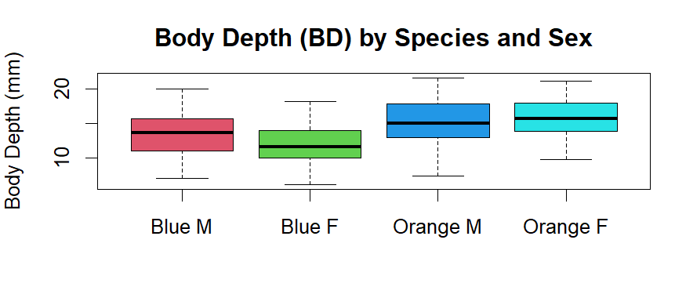
Figure 2. A box and whisker plot of body depth of the four groups by species and sex
There are no outliers in the data set.The data for all four compositions appear symmetric or normally distributed.

b)
###central tendency between groups by species and sex

list(crabs$species, crabs$sex)
##Mean
Mean_sp_sex<-tapply(crabs$BD, list(crabs$sp, crabs$sex), mean)
##Median
Median_sp_sex<-tapply(crabs$BD, list(crabs$sp, crabs$sex), median)

##Variance
Variance_sp_sex<-tapply(crabs$BD, list(crabs$sp, crabs$sex), var)

Mean
F M
B 11.816 13.350
O 15.632 15.324

Median
F M
B 11.60 13.6
O 15.65 15.0

Variability
F M
B 7.576065 10.23929
O 7.576914 12.44104

The mean and median for all the groups are approximately the same. Crabs that are orange and male have the largest variability in the data set and crabs that are blue and female an orance and female have the same variance.

QUESTION 3
a)
##Histogram of CL for each species
par(mfrow=c(1,2))
# Histogram for species B
Histogram_Blue<-hist(crabs$CL[crabs$sp == "B"],
main = "",
xlab = "Carapace Length (CL)for B",
col = "lightblue")
# Histogram for species O
par(mfrow=c(1,2))
# Histogram for species B
Histogram_Orange<-hist(crabs$CL[crabs$sp == "O"],
main = "",
xlab = "Carapace Length (CL)for O",
col = "red")

A Histogram of carapace length for both species
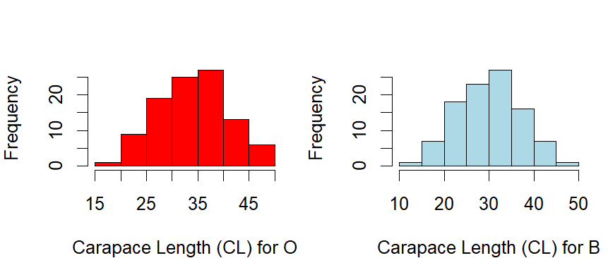
Figure 3 .A histogram of CL for both species

- Both datasets are unimodal, they all have a single modal value. The histogram for orange species appears to be symmetric to the left and the histogram for Blue appears to be slightly skewed to the right.

QUESTION 5
a)
###Scatter plot of the five measurements
par(mar=c(4,4,4,1))
pairs(crabs[, 4:8],
main = "Scatter Plot of Crab Measurements",
col = "black")

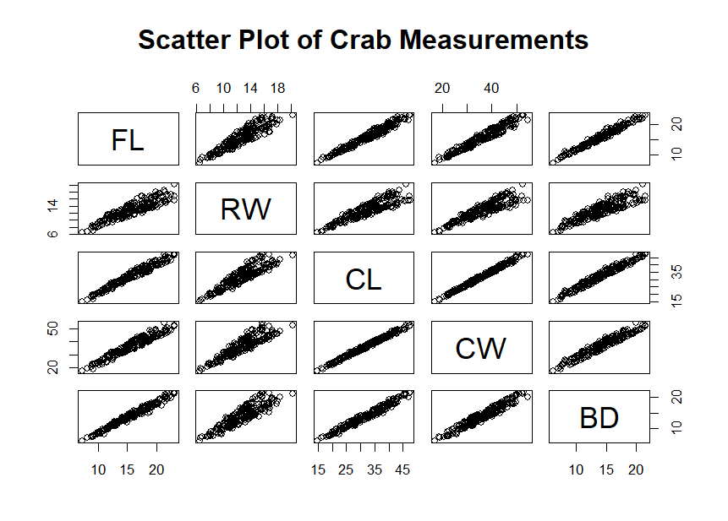
Figure 4. A scatter plot of the five measurements

b)There is a positive relationship between all the five measurements. The measurements are positively correlated.

QUESTION 4
a)
###Comparison of mean measurements

# Create 4 groups

B_F <- crabs[crabs$sp=="B" & crabs$sex=="F", ]
B_M <- crabs[crabs$sp=="B" & crabs$sex=="M", ]
O_F <- crabs[crabs$sp=="O" & crabs$sex=="F", ]
O_M <- crabs[crabs$sp=="O" & crabs$sex=="M", ]
means_table <- data.frame(
Group = c("B_F", "B_M", "O_F", "O_M"),
FL = c(mean(B_F$FL), mean(B_M$FL), mean(O_F$FL), mean(O_M$FL)),
RW = c(mean(B_F$RW), mean(B_M$RW), mean(O_F$RW), mean(O_M$RW)),
CL = c(mean(B_F$CL), mean(B_M$CL), mean(O_F$CL), mean(O_M$CL)),
CW = c(mean(B_F$CW), mean(B_M$CW), mean(O_F$CW), mean(O_M$CW)),
BD = c(mean(B_F$BD), mean(B_M$BD), mean(O_F$BD), mean(O_M$BD))
)
means_table

Group FL RW CL CW BD
1 B_F 13.270 12.138 28.102 32.624 11.816
2 B_M 14.842 11.718 32.014 36.810 13.350
3 O_F 17.594 14.836 34.618 39.036 15.632
4 O_M 16.626 12.262 33.688 37.188 15.324

b)
par(mar = c(4,4,3,1))
bar_data <- as.matrix(means_table[, 2:6])
rownames(bar_data) <- means_table$Group

barplot(bar_data,
beside = TRUE,
main = "Mean Measurements",
xlab = "Measurement",
ylab = "Mean",
legend.text = rownames(bar_data),
col =2:6,
args.legend = list(x = "topright"),ylim = c(0,50))

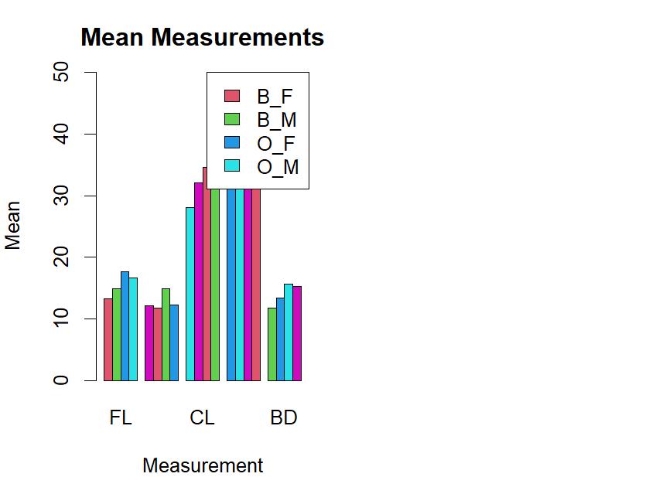

QUESTION 6
A COMPREENSIVE REPORT ON THE DESCRPTIVE ANALYSIS OF THE CRABS DATASET
The crabs data set contains 200 sampled from two species. It also records sex and five key measurements.
The bar chart in Figure 1 shows that the data is balanced and are of the same sample size. Across the four groups shown in he boxplot in Figure 2, males generally have a larger body depth compared to the females. The means and medians are also similar making the data symmetric. For Carpace length, the species B are slightly skewed to the right while species O appear to be symmetric, both data sets are unimodal, that is they have one distinct modal value.
The dataset shows clear species and sex patterns, with larger males and O species.

